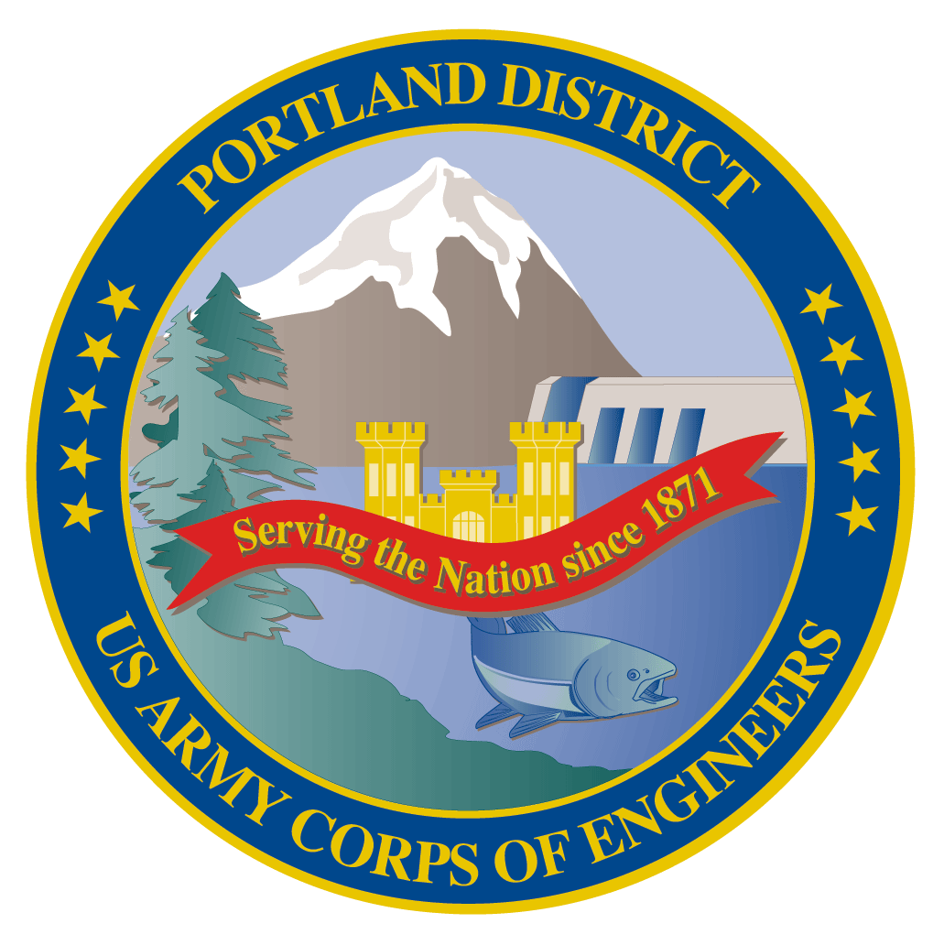Lower Columbia River Fish Facility Design Review Work Group (FFDRWG)

USACE, Portland District

# June 2021 Meeting Agenda

June 3, 2021 09:00-11:00

Join Meeting: <https://usace1.webex.com/usace1/j.php?MTID=m5c365c1bf762dad74cbaa2985e8e04fb>

Meeting password: FFDRwG2021!

*(*if using your phone for audio, log in through Webex and have the meeting call you)*

Join by phone (audio only, no Webex): (844) 800-2712 | Access Code: 199 571 1422

## Introductions

FFDRWG members:

**BPA**

Scott Bettin

Kim Johnson

Siena Lopez-Johnston

Christine Petersen

Greg Smith

Leah Sullivan

Ben Hausmann

**NOAA**

Blane Bellerud

Gabriel Brooks

Trevor Conder

Kinsey Frick

Claire McGrath

Josie Thompson

Logan Negherbon

**USFWS**

Dave Swank

**States**

Erick Van Dyke (ODFW)

Charles Morrill (WDFW)

**CRITFC/Tribes**

Tom Lorz (CRITFC)

Blaine Parker (CRITFC)

Tom Skiles (CRITFC)

Casey Baldwin (CTCR)

Michael Karnosh (CTGR)

Lawrence Schwabe (CTGR)

Torey Wakeland (CTGR)

Aaron Jackson (CTUIR)

Ralph Lampman (YN)

**NPCC**

Leslie Bach

Kris Homel

**FPC**

Erin Cooper

**PSMFC**

Alan Brower

Darren Chase

Roger Clark

Mark Leonard

Scott Livingston

Nicole Tancreto

Don Warf

**CENWD**

Doug Baus

Tim Dykstra

Dan Feil

Mike Langeslay

Cindy Studebaker

Sean Tackley

Lisa Wright

**CENWW**

Karl Anderson

Chris Peery

Marvin Shutters

Denise Griffith

**CENWP-OD**

Andrew Derugin

Rebecca Cates

Jeanette Wendler

Bob Cordie

Jeffrey Randall

Scott Fielding

Eric Grosvenor

Michael Lotspeich

Laura Rickets

Tammy Mackey

Darren Gallion

Nathan McClain

Robert Wertheimer

Karrie Gibbons

**CENWP-PM**

Jim Adams

Eric Bluhm

Ian Chane

Jeff Hicks

Steve Sipe

Bob Winters

Brad Eppard

David Griffith

Fenton Khan

Rachel Laird

Jake Macdonald

Rich Piaskowski

Jon Rerecich

Ida Royer

David Trachtenbarg

Jeremiah Woodard

Erin Kovalchuk

**CENWP-ENC**

Adam White

Brandt Bannister

Bridget Bell

Jonathon Brink-Roby

Shari Dunlop

Laurie Ebner

Curtis Lipski

Chris Motti

Steve Schlenker

Max Wilson-Fey

Mehdi Roshani

## Action items from last meeting

* Weiland et al (2016) was sent to FFDRWD by Jake Macdonald on 5/14 (relevant to discussion over Bonneville spillway survival)
* Axel et al (2020) was sent to FFDRWD by Christine Petersen on 5/6 and Jake Macdonald on 5/14 (relevant to discussion over the PIT barge at Bonneville)

## Topics for FFDRWG Discussion/Review/Coordination

* BON spillway rock removal/mitigation – Jeremiah Woodard (PM), Max Wilson-Fey (TL), Jacob Macdonald (FC)
  + Draft modeling report was sent to FFDRWG by Jake Macdonald on 6/1. Questions/comments?
* BON adult lamprey passage improvements: Washington Shore control section redesign – Bob Winters (PM), Shari Dunlop (TL), Jacob Macdonald (FC)
  + Scope update
* BON adult lamprey passage improvements: Bradford Island Ladder extensive minor modifications to serpentine section for lamprey – Bob Winters (PM), Adam White (TL), Jacob Macdonald (FC)
  + FFDRWG input on scope/scale
* JDA adult lamprey passage improvements: North Fish Ladder LPS water supply upgrade – Eric Bluhm (PM), Adam White (TL), Jacob Macdonald (FC)
  + Water supply (gravity fed?)
* TDA adult lamprey passage improvements: East Fish Ladder junction pool LPS – Eric Bluhm (PM), Adam White (TL), Jacob Macdonald (FC)
  + Water supply (gravity fed?)

## Written project updates

* JDA turbine rehab – Steve Sipe (PM), Curtis Lipski (TL), Jon Rerecich (FC)
* TDA AWS Debris Management– Erin Kovalchuk (PM), Mehdi Roshani (TL), Jon Rerecich (FC)
* BON Second Powerhouse FGE – Jim Adams (PM), Bridget Bell (TL), Jon Rerecich (FC)
* JDA adult lamprey passage improvements: South Ladder entrance improvements (rounded crest, slot filler) – Eric Bluhm (PM), Adam White (TL), Jacob Macdonald (FC)

* TDA adult lamprey passage improvements: East Fish Ladder control section weir modifications – Eric Bluhm (PM), Adam White (TL), Jacob Macdonald (FC)
* BON adult lamprey passage improvements: LPS pump upgrades – Bob Winters (PM), Andrew Derugin (TL), Andrew Derugin (FC)
* BON adult lamprey passage improvements: Bradford Island B-Branch entrance improvements (variable width entrance weir, bollards, and transition pool LPS) – Bob Winters (PM), Adam White (TL), Andrew Derugin (FC)
* BON adult lamprey passage improvements: Cascades Island LPS flume modifications – Bob Winters (PM), Andrew Derugin (TL), Andrew Derugin (FC)

Next meeting: July 1st @ 09:00